**COVID-19: an opportunity to review fieldwork provision**

Gayle Sloggett

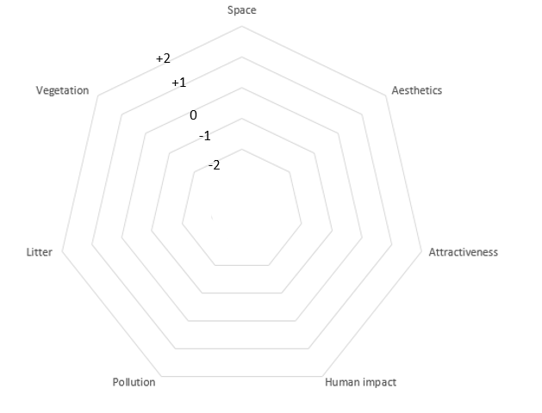**Data presentation**

Site:

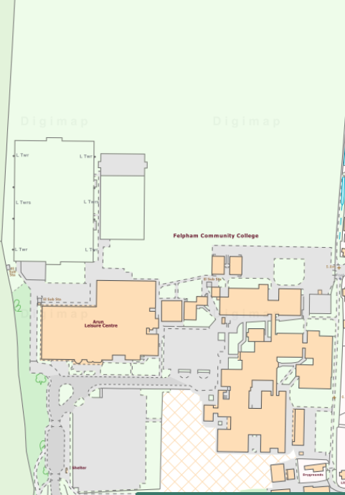

Site:

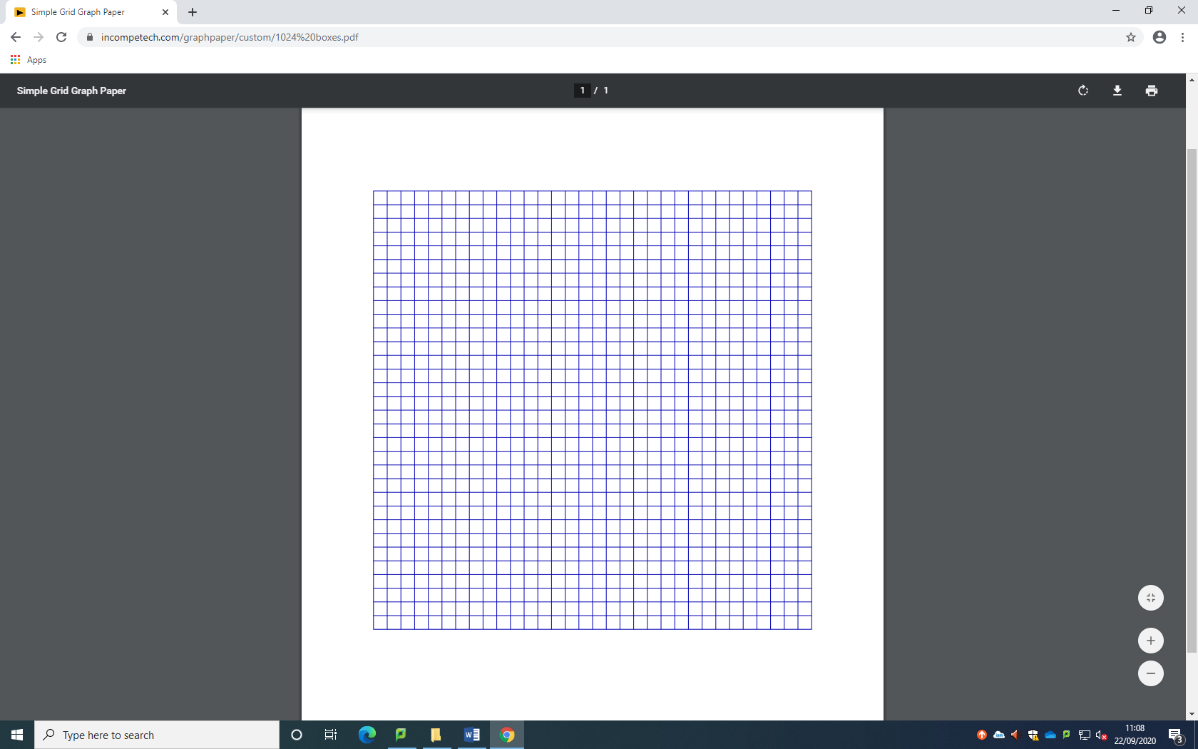**Species count**